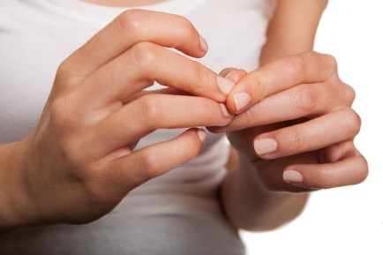
=

If I earn _______ happy faces, I get ______________________________

If I earn _______ happy faces, I get ______________________________

Instructions for this template:
Tokens are earned when the individual does not pick at his/her nails and/or skin over a predetermined amount of time. For this token board, the happy faces above are printed, cut out, and laminated. The token board (first page) is also laminated, and Velcro is used to on the board and tokens, so that tokens can be stuck to the board as they are earned.

