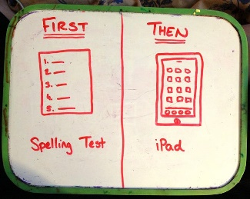
FIRST-THEN
Then...
First..

First-Then Statements/Boards
First-then statements/boards describe a sequence of events that will occur. This can be helpful for showing which transitions/activities will occur and in what order. These statements are also commonly used to motivate an individual to complete a non-preferred activity, by rewarding completion of that activity with a preferred activity
- “First do your homework, then you can play videogames”

How to implement first-then statements/boards:
- Arrange tasks so that a difficult or non-preferred task occurs before a preferred activity
  - For example, “First clean up, then you can play videogames.”
- Once the “first” task is completed, move onto the “then” activity as immediately as possible
- Ensure that the “then” (preferred activity) is only given after the “first” (non-preferred activity) is completed
- Use pictures or words on the first-then board depending on what the individual understands/prefers
  - A visual is not absolutely necessary, a verbal statement may be sufficient depending on the individual!
- Ensure you accurately identify preferred and non-preferred activities/items
DO | DO NOT
- Put the “first” activity as a non- preferred activity | - Give the preferred “then” activity before the “first” activity is complete even if challenging behaviours occur
- Put the “then” activity as a preferred activity that he/she likes | - Put extremely difficult unknown tasks as the “first” activity
- Ensure the expectation is clear – e.g. for “Clean your room”, how clean does it need to be? Exactly what needs to be completed? | - Assume that a “then” activity for one person will work for everyone – individualize!
- Keep the first-then board visible | - Use words on the board if the individual cannot read

